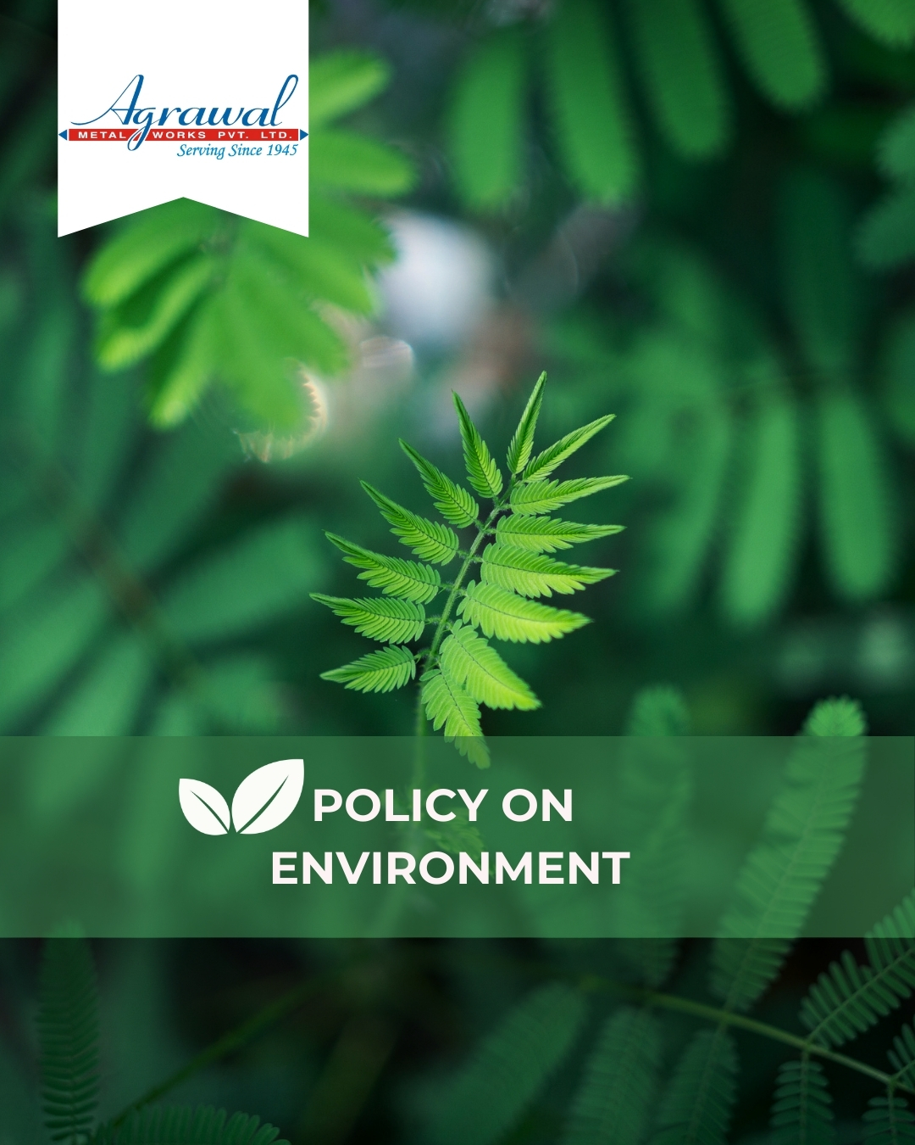

Contents
INTRODUCTION 2
SCOPE 2
POLICY STATEMENT 3
KEY FOCUS AREAS 3
COMMITMENT AND GOALS 4
HARMONIZING ENVIRONMENTAL PRACTICES WITH SUSTAINABLE DEVELOPMENT GOALS 5
RESPONSIBILITIES 6
REPORTING 6
REVIEW MECHANISM 7
REVISION HISTORY 7
EMPLOYEE ACKNOWLEDGEMENT & COMMITMENT 8

INTRODUCTION

At Agrawal Metal Works Pvt. Ltd., a premier manufacturer of Copper and Copper Alloys Semis, we recognize our duty to protect the environment. As a prominent player in the metal industry, we are committed to integrate sustainable practices and environmental responsibilities into every aspect of our business. Our environmental policy is designed to minimize our ecological footprint, promote resource efficiency, and contribute to the well-being of the communities we serve.

To uphold our commitment to environmental protection, Agrawal Metal Works has implemented a "Zero Liquid” Discharge Policy which is being achieved through the utilization of advanced Effluent Treatment Plants (ETP) and Sewage Treatment Plants (STP), ensuring that no harmful discharge affect to our surroundings. Furthermore, we have established a dedicated Air Pollution Control System to maintain the quality of air emissions, thereby protecting the atmosphere. By adhering to stringent environmental standards and continuously seeking innovative solutions, Agarwal Metal Works aims to lead in the journey towards a greener and more sustainable future.

SCOPE

This Policy is applicable to following sites and all of its employees, workers, sub-contractors and other stakeholders:

Sr. No. | Site | Address
1 | Agrawal Metal Works Pvt. Ltd. | SP-144, RIICO Ind. Area, Phase-1, Bhiwadi – 301019, Maharastra, India
2 | Agrawal Metal Works Pvt. Ltd. | Jhajjar Road, Rewari-123401, Haryana, India
3 | Agrawal Metal Works Pvt. Ltd. | 205, “Arunachal Building” 19, Barakhamba Road –110001, New Delhi, India

POLICY STATEMENT

At Agrawal Metal Works Pvt. Ltd., we are dedicated to conducting our operations in a manner that prioritizes environmental sustainability and minimizes our ecological footprint. The goal is to integrate responsible practices that preserve natural resources and enhance environmental quality for future generations, building on the baseline set for FY 2019-20.

KEY FOCUS AREAS

- Energy Efficiency & Emission Reduction – Implementing energy-efficient technologies and optimizing processes to minimize carbon/Energy footprint and greenhouse gas emissions.
- Water Resource Management – Reducing water consumption through recycling, reuse initiatives, and responsible wastewater treatment. Enhancing the process of reduction in quantum of ground water with use of treated water.
- Responsible Material & Chemical Use – Ensuring safe handling of chemicals, following the MSDS sheet, minimizing hazardous substances, and promoting use of scrap materials as a part of raw material for our sustainable environment.
- Air Quality & Pollution Control – Implementing advanced filtration, treatment methods and emission control systems to maintain compliance with air, noise and water quality standards.
- Waste Reduction & Circular Economy – Maximizing material recovery and yield output, minimizing waste generation, and promoting recycling and reuse strategies.
- Customer Health & Safety – Ensuring product safety, reducing environmental and safety risks, and promoting sustainable practices in customer use.
- Biodiversity & Ecosystem Protection – Minimizing environmental impact on local ecosystems through responsible land use and conservation efforts.
- Legal Compliance & Environmental Advocacy – Engaging in sustainability initiatives, complying with environmental regulations and norms, and promoting eco-conscious industry practices.
- Innovation in Green Technologies – Investing in R&D for eco-friendly solutions, process improvements, and sustainable product innovation.

COMMITMENT AND GOALS

- Conduct feasibility studies to develop and enhance the energy efficiency technology through audits and upgrades, and explore financial incentives and partnerships for cost-effective implementation.
- Achieve a 20% reduction in greenhouse gas emissions intensity till FY 2029-30 from the base year.
- Expand green spaces within the factory premises to increase green coverage by 40% by FY 2029-30, aiming to significantly reduce the factory’s carbon footprint through enhanced green initiatives.
- To enhance water conservation practices and ensuring stringent monitoring and maintenance of the treatment equipment to maintain the water quality standards of treated water.
- Maintain 100% compliance with regulatory water quality standards through continuous monitoring and improvement by FY 2029-30.
- To regularly optimize the existing Air Pollution Control Systems to exceed regulatory requirements and maintain air quality standards.
- Invest in technologies to reduce air emissions by 25% from manufacturing processes by FY 2029-30.
- To report the quantities of the major waste such as metallic waste, chemical waste, electroplating waste generated and make efforts to reduce, recycle, and maintain sustainable disposal practices of the waste.
- To achieve a 10% reduction in waste generation by FY 2029-30 by integration of waste reduction and recycling initiatives.
- Actively participate in local biodiversity conservation efforts through habitat preservation and restoration initiatives like land conservation, native planting under environment responsibility.
- Plant and maintain 500 native trees and shrubs within and around the operational premises and nearby community areas by FY 2029–30.
- Allocate 5% of the facility’s open land area for biodiversity conservation zones, including habitat restoration and protection, by FY 2029–30.
- Maintain stringent product safety standards and continuously improve product quality to ensure customer satisfaction.
- Maintain 100% compliance with all applicable product safety regulations and standards across every product line, with third-party audits for verification by FY 2029-30.
- Expand community environmental education programs to raise awareness and foster sustainable practices.
- Advocate for policies that support environmental protection, sustainable development, and responsible resource management at local and regional levels.
- Engage 500 community members annually through environmental education development programs by FY 2029-30.

HARMONIZING ENVIRONMENTAL PRACTICES WITH SUSTAINABLE DEVELOPMENT GOALS

At Agrawal Metal Works Pvt Ltd, our Environmental policy aligns with the following given SDGs.

 | 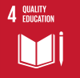 |  | 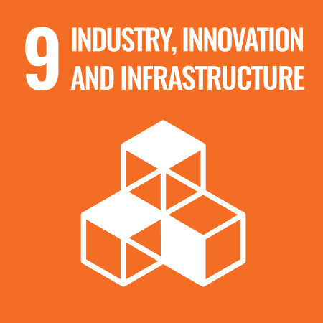
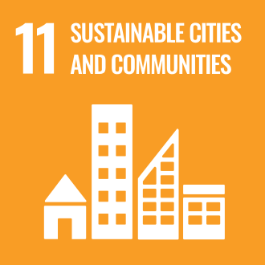 |  |  | 

RESPONSIBILITIES
At Agrawal Metal Works, environmental sustainability is driven through defined roles across all functions:
- Senior Management: Integrate sustainability into business strategy, allocate resources, and review environmental performance. Senior management is responsible to provide a safe and environmentally friendly workplace for their workers, employees and auditors.
- Environment & Safety Team: Implement sustainable initiatives, conduct internal as well as external audits, and monitoring of environmental parameters in term of energy, water, and emissions. The EHS team shall monitor all physical and occupational health hazards in the workplace, report them to top management, and take corrective action in case of any issues. All local and national legal and regulatory requirements shall be closely monitored and complied with by the Environment and Safety team.
- Operations & Maintenance Teams: Optimize energy use, manage emissions, and support water recycling and waste reduction. Section In-charges shall conduct trainings for their workers to promote good practices and maintain a clean, pollution-free environment.
- Supply Chain & Procurement Teams: Source recycled materials, engage responsible vendors, and promote sustainable inputs. Regulatory compliance documents shall also be collected from supply chain partners and verified by the Environment and Safety Officer.
- Employees: Follow environmental practices, conserve resources, and actively contribute to sustainability goals.
- R&D & Engineering Teams: Innovate cleaner technologies, improve process efficiency, and reduce environmental impacts by comparing new and existing technologies with a focus on environmental parameters and their effects.
- Legal Team: Ensure compliance with all regulatory requirements, monitor whether records are properly maintained, and provide support for certifications and audits.

REPORTING

- Environmental Performance Metrics: Provide annual updates on energy efficiency improvements, greenhouse gas emissions reductions, and water conservation efforts.
- Waste and Chemical Management: Report annually on waste generation reduction initiatives, recycling rates, and advancements in chemical management practices to enhance safety, sustainability and waste reduction.
- Community Engagement and Advocacy: Regularly report on community engagement activities, environmental education programs, and collaborative efforts with stakeholders to advocate for sustainable practices and environmental policy support.
- Sustainability Initiatives and Innovations: Provide updates on new sustainability initiatives implemented each year and their impact on environmental sustainability.

REVIEW MECHANISM

To ensure continual progress and effectiveness of our sustainability efforts at Agrawal Metal Works, we have established the following robust review mechanism:
- Annual Sustainability Assessment: Conduct yearly evaluations of environmental performance in key areas like energy, emissions, water, air quality, waste, biodiversity, customer safety, and community engagement.
- Cross-Functional Review: Involve Environment, Health, Safety, Operations, and Quality Assurance departments for a comprehensive policy review.
- Feedback and Improvement: Gather feedback from stakeholders, develop actionable recommendations, and implement continuous improvement
This policy will be reviewed by the Environmental Manager on annual basis, to ensure accountability, transparency, and proactive management of environmental responsibilities at Agrawal Metal Works Pvt. Ltd.

REVISION HISTORY

Amendment of Revision No. | Effective Date | Details of Amendment of Revision
00 | 01.01.2023 | New Policy Draft
01 | 01.01.2024 | Scope
01 | 01.01.2024 | Commitment and Goals
01 | 01.01.2024 | Review Mechanism
02 | 01.01.2024 | Key Focus Areas
02 | 01.01.2024 | Responsibilities
03 | 01.01.2025 | Key Focus Areas
03 | 01.01.2025 | Commitment and Goals
03 | 01.01.2025 | Harmonizing environmental practices with SDG
03 | 01.01.2025 | Responsibilities

REV. No. 02

LAST REVIEW DATE: 01.01.2025 NEXT REVIEW DATE: 01.01.2026
APPROVED BY:

EMPLOYEE ACKNOWLEDGEMENT & COMMITMENT

I hereby acknowledge that I have read and understood the Environmental Policy of Agrawal Metal Works Pvt. Ltd. I am aware of the company’s commitment to responsible environmental practices, including energy efficiency, resource conservation, waste management, pollution control, and compliance with all applicable environmental laws and regulations.

I understand that environmental sustainability is a shared responsibility, and I commit to incorporating sustainable practices in my daily tasks, minimizing waste, optimizing resource use, and ensuring adherence to established environmental guidelines. I will actively contribute to achieving the company’s sustainability goals and support initiatives that promote a cleaner, safer, and more sustainable workplace.

By signing this document, I confirm my commitment to upholding Agrawal Metal Works Pvt. Ltd environmental values and participating in training, awareness programs, and improvement initiatives as required.

Employee Name  Employee ID  Date  Signature | :_______________________________  :_______________________________ :________________________________  : _______________________________

